# Project Progress Report-1

# (Submission Date: 18 Feb 2019)

**E-MAIL SPAM DETECTOR**

**BACHELOR OF ENGINEERING**

**IN**

**COMPUTER SCIENCE & ENGINEERING**



**Submitted By: Name of the Mentor:**

ARINDAM(17BCS1780) Manpreet Kaur

SURAJ(17BCS1769)

RAHUL(17BCS1811)

**Roll No:**

17BCS1780

17BCS1769

17BCS1811

**DEPARTMENT OF COMPUTER SCIENCE & ENGINEERING**

**Chandigarh University, Gharuan**

**PROJECT GOAL**: The goal of the project is to design an E-mail spam detector which detects the spam in e-mails and it sends to the trash box in spam section, It determines the spam e-mail itself as its designed in such a way which we call self automization(.i.e. which detects the spam e-mails itself). As soon as we receive the spam e-mail it starts functioning and informs us about the spam email server automatically. It is coded in python programming language.

**PROJECT WORK DONE TILL DATE:** The project is completed a month before submission. Its functioning properly and its able to detect the spam emails and sending it in the trash section.

**WORKING MODEL OF THE PROJECT:**

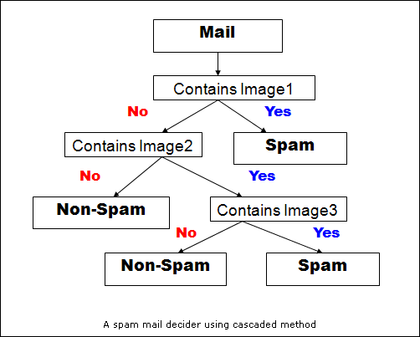

**Modules:**

* **class Spam_Classifier Object:** It is basically used to divide the keywords in terms of list so that the model can be used to find the repeatence of the word in the list and find out is there is any need to consider the word in the group or not.
* 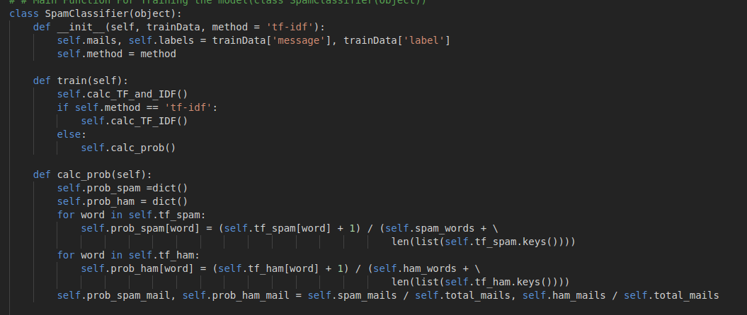
* **Tkinter box:** It is used to show the message in the result from the def alldonewithflyingcolors(pm,new) is going to show the result through the text box.
* 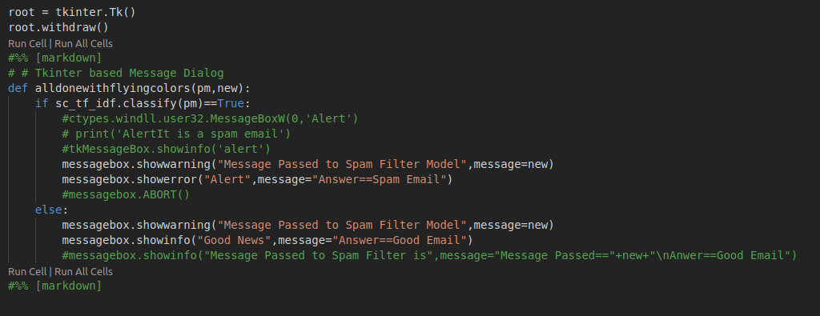**process_message(new)==** new is the string which used to take the string in it and send it to the Spamclassifierobject so that it can further process it.

**SCREENSHOTS OF RUNNING PROJECT TILL DATE:**

